Task Hours Achieved - Sprint 3

Assignment Specification: Task Hours
In this assignment you will document what you worked on in the Sprint. I want you to put your user story with all the tasks that were completed. This will be helpful for your portfolio. Here is an example. Please note the use of hyperlinks.

Sprint-1 Minimal Viable Product

Introduction
In this Sprint, the purpose was to create a minimal viable working product. The following sections contain the User Stories I worked on with a detailed description of the Tasks I worked on.

User Stories
I worked on the following User Story:

US3: As a student, I want clear feedback on my answers, including hints and explanations, so that I can learn from my mistakes.

Conditions of Satisfiability
- Immediate Feedback: Feedback on answer correctness is provided immediately after the student submits their response.
- Correct Answer Indication:
  - Correct answers are clearly marked as such, with a visual cue (e.g., green checkmark, positive message).
- Incorrect Answer Feedback: Incorrect answers trigger a clear indication of incorrectness (e.g., red "X", negative message) and provide the following:
  - Correct Answer: The correct answer is displayed prominently.
  - Explanation: A concise, easy-to-understand explanation of why the correct answer is correct is presented.
  - Hint (Optional): A hint is offered to guide the student towards the correct answer, either automatically or upon request.

Definition of Done
- Code Complete: All code related to the User Story has been written, reviewed, and merged into the main branch.
- Tested: Thorough testing (unit, integration, and acceptance) ensures:
  - Correct answers are properly identified and displayed.
  - Incorrect answers trigger the appropriate feedback mechanisms (incorrect answer indication, display of correct answer, explanation, and optional hint).
  - Hints, if implemented, are helpful and guide the student towards the correct answer.
- UI/UX Design:
  - The feedback interface is visually clear, easy to understand, and integrated seamlessly into the assessment flow.
  - Feedback messages are concise, informative, and use language appropriate for the target audience.
  - Visual cues for correct/incorrect answers are distinct and easy to interpret.
- Explanation and Hint Content:
  - Explanations are accurate, comprehensive, and tailored to the specific question and answer.
  - Hints (if implemented) are relevant, provide useful guidance without giving away the answer, and are optional for the student to reveal.
- Accessibility: The feedback interface adheres to accessibility guidelines to ensure all students, including those with disabilities, can understand and benefit from the feedback.
- Performance: The feedback mechanisms do not introduce significant delays or negatively impact the performance of the assessment.
- CoS Met: All the Conditions of Satisfaction listed above have been verified and met through testing and review.

Tasks
- US3 Design feedback UI elements (correct/incorrect, explanations, hints) (3 ph) #24Links to an external site.
- Links to an external site.US3 Develop backend logic for answer checking (4 ph) #25Links to an external site.
- Links to an external site.US3 Integrate feedback UI with backend logic (2 ph) #26Links to an external site.
- Links to an external site.US3 Create/gather explanations and hints (if applicable) (5 ph) #27Links to an external site.
- US3 Thoroughly test all feedback mechanisms (2 ph) #28Links to an external site.

etc. Other User Stories you worked on go here

Tasks I Worked On
US3 Design feedback UI elements (correct/incorrect, explanations, hints) (3 ph) #24s .

I developed a panel widget that counted the number of correct and incorrect answers. The explanations are taken care of by the Tutor agent. The task was estimated at 3 person hours but took 5 to complete.
Your example should be more detailed but you get the idea.
Continue for all tasks worked on .
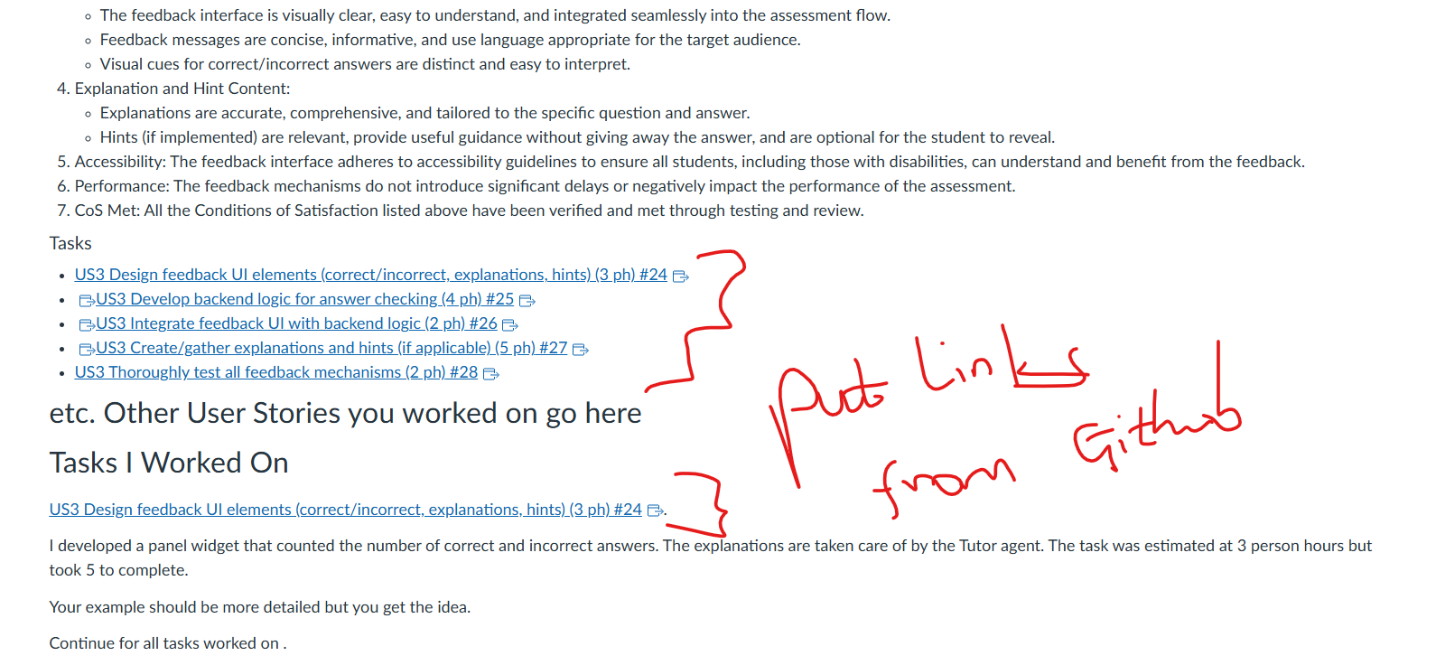

Summary Table of Work
Note use of hyperlinks.
UserStory GitHub Issue ID | User Story | Story Points | Task GitHub Issue ID | Task | Task Hours | Status | Actual Hours
3. | As a student, I want clear feedback on my answers, including hints and explanations, so that I can learn from my mistakes. | 3 | 24. | US3 Design feedback UI elements (correct/incorrect, explanations, hints) | 3 | Complete | 5
etc...
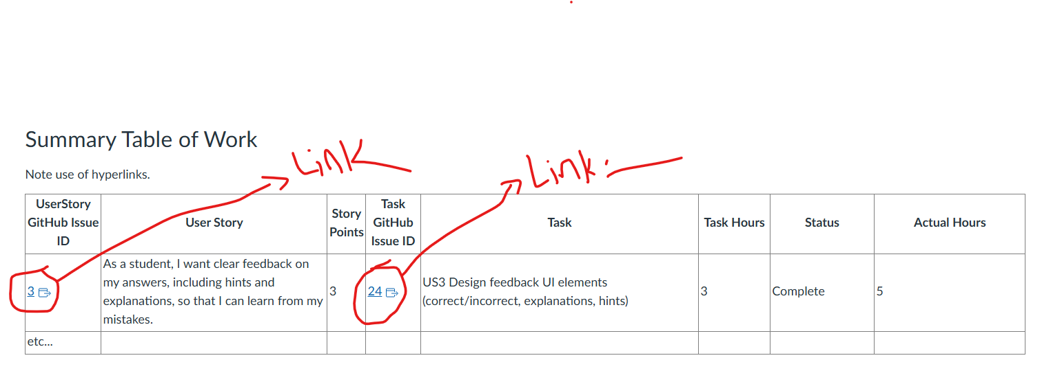

Summary Table of Commits
Note use of hyperlinks. You can find your commits by going to the Code tab and just below the Green Code dropdown there is a hyperlink to the commits. I'm only want the commits that were merged into the Sprint branch.
Date | Commit Number | Commit Description (exactly as in github) | User Story | Task
5/21/2024 | 55b653a. | working tutor | 3Links to an external site. | 24Links to an external site.
etc...

Upload as a summary table in a single Word document a file that looks like the above for everything you worked on.
